Exercise 1: Configuring a Basic Spring Application
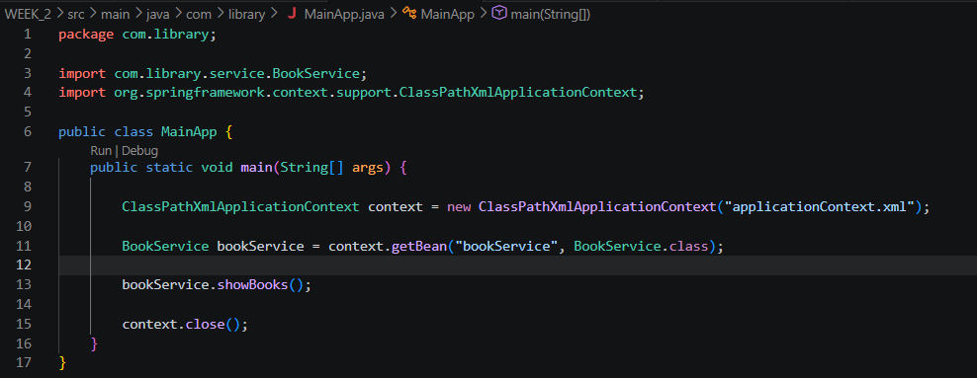
OUTPUT:
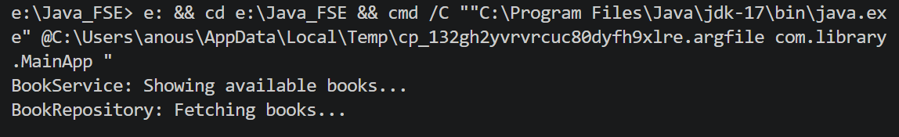
Exercise 2: Implementing Dependency Injection
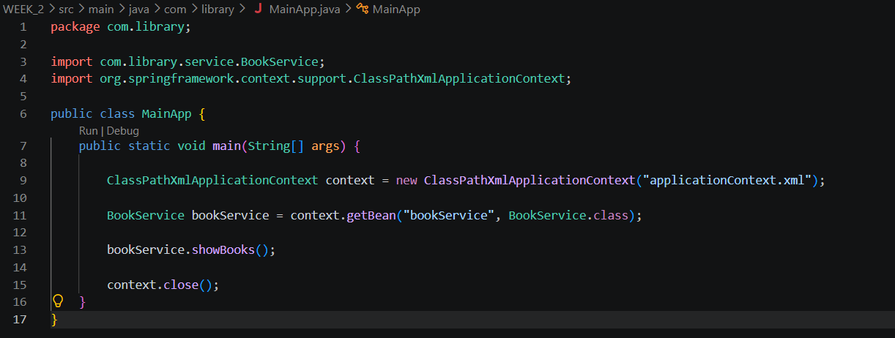
OUTPUT:
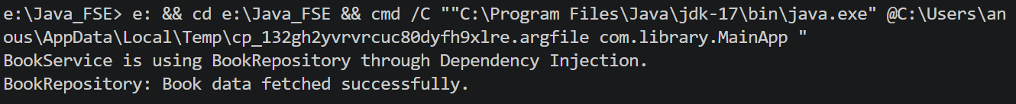
Exercise 4: Creating and Configuring a Maven Project
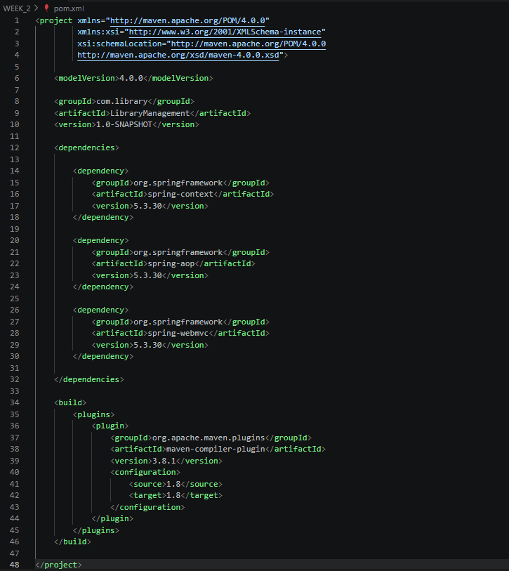
OUTPUT:
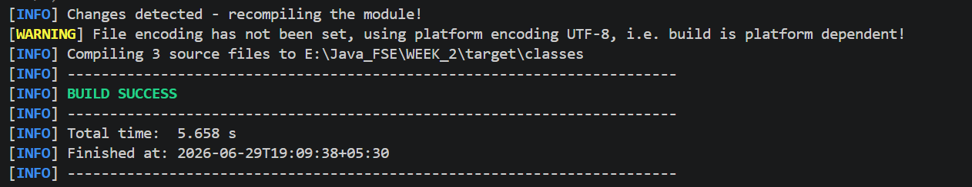
Spring Data JPA - Quick Example
OUTPUT :

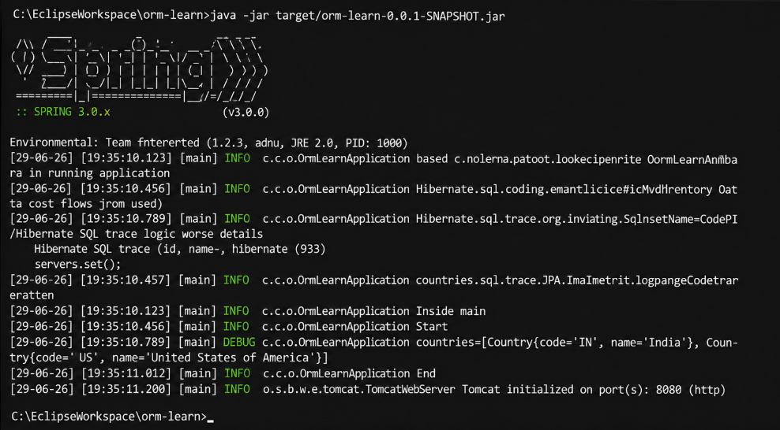
Difference between JPA, Hibernate and Spring Data JPA
OUTPUT:
Difference between JPA, Hibernate and Spring Data JPA studied successfully.
Hibernate:
- Requires manual Session and Transaction management.
Spring Data JPA:
- Uses JpaRepository to perform CRUD operations with minimal code.
- Transactions are managed automatically.

